|  |  |
| --- | --- |
|  | Information Requirements |

1. Overview of your Genpact’s full capabilities for providing IT & value added services

Genpact is a global leader in transforming and managing complex and industry-specific business processes and operations. The Genpact name and brand are derived from our overarching goal – to **Generate Impact.** This is the business impact visible in the tighter management of costs, risks, regulations, and growth for hundreds of our long-term clients. Our goal, simply stated, is to help Synchrony Financial become more competitive by providing IT services that will help its business adapt, innovate, and perform at a higher level.

Traditional IT Management Services

Genpact is a global IT management services provider that plans, designs, and implements organizational IT strategies and manages mission-critical IT infrastructure for global clients. Genpact leverages its in-depth industry and technical knowledge and helps Synchrony Financial extract maximum value from its IT investments. The company delivers this by providing an IT infrastructure management platform that is cost effective, reliable, and cutting edge. Genpact recognizes that, like many of its clients, Synchrony Financial may be experiencing new and often times disruptive trends in delivering IT services to meet the needs of its business. Accordingly, Genpact offers a full suite of traditional IT services as well as a migration path to introduce and enable 21st century digital IT strategies and services.

**Genpact’s End-user Services**

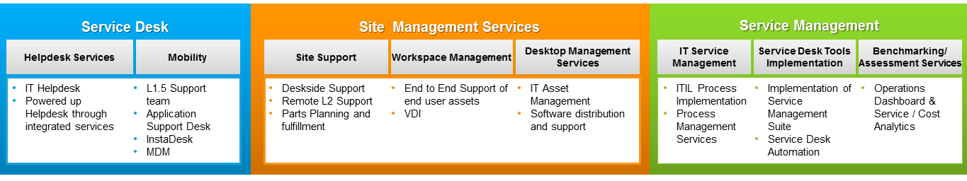

**Genpact’s Infrastructure Services**

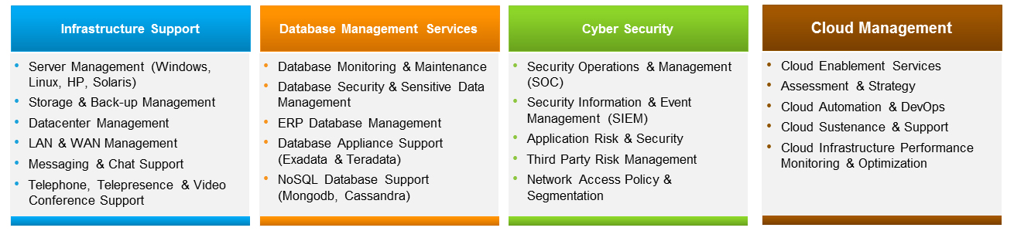

* Genpact provides support for >1 M end users and the monitoring of 400,000+ infrastructure devices globally
* Genpact’s experience in developing BPO/ITO solutions in diverse market sectors, e.g., consumer banking and retail finance, insurance, manufacturing, IT, healthcare, media, and broadcasting, enables it to leverage and apply best practices “horizontally” across its entire client base
* Though supplier agnostic when solutioning customer needs, Genpact possesses a comprehensive technology management platform that includes best-of-breed technology partner tools and services as well as Genpact proprietary tools and process frameworks
* Genpact’s Partner Program enlists best-of-breed vendors and alliances continuously to drive down costs, reduce defects, and improve productivity
* Genpact offers flexible and customized solutions that match specific customer needs
* Genpact has a global footprint and an integrated onshore, near-shore, and offshore delivery network
* Genpact provides 24x7 support in 25+ languages, guaranteeing standardized services for global businesses

Genpact’s IT management services have incorporated automation, simplification, documentation and controls, quality support, and industrialized reviews into its operating model. By combining Six Sigma, Lean, and Root Cause Corrective Action (RCCA) methods to proactively eliminate defects in the IT infrastructure, Genpact’s relentless focus on quality, backed by its robust proprietary tools and methodologies, ensures its ability to:

* Deliver better levels of service with a flexible, yet robust global delivery model
* Improve infrastructure utilization
* Increase infrastructure availability
* Boost end-user satisfaction
* Reduce Total Cost of Ownership for IT service delivery and infrastructure
* Improve visibility for the client technical environment
* Maximize operational efficiency

We are called upon to provide L1 to L3 skill sets and support, and do so in 25+ languages with a global footprint of native speakers. We can provide the monitoring and management of Synchrony Financial data centers, servers, storage, e-mails, networks, databases, applications, and end-user devices. We use a network of digital Remote Operations Centers (ROCSM) to provide 24x7 infrastructure monitoring and management capabilities. Along with ITIL and ISO 20000 certifications, we employ Six Sigma and Lean principles to address technology problems and enable Synchrony Financial to align its IT to business priorities and, at the same time, reduce technology costs. Our proprietary SEPSM and Service Disruption to Restore (D2R), along with our accelerators and IP frameworks, enable us to continuously reduce defects and create business priority-driven outcomes. We also provide design, consulting, and operational services to support cloud enablement, ITIL/IT Service Management (ITSM) implementation and development, and comprehensive “X”-a-a-S ecosystem management.

**Genpact’s Digital IT Services**

Genpact’s Digital practice can help Synchrony Financial reimagine its business operations with an innovative set of advanced technologies along with differentiated core IT services that drive transformative solutions. Our Systems of Engagement solutions provide an engagement layer of agile, nimble technologies that address end-to-end business processes and are built using social, mobility, big data, and cloud-based technologies on a foundation of deep process experience and domain expertise.

**Our digital IT services include design, build, and run capabilities and consist of:**

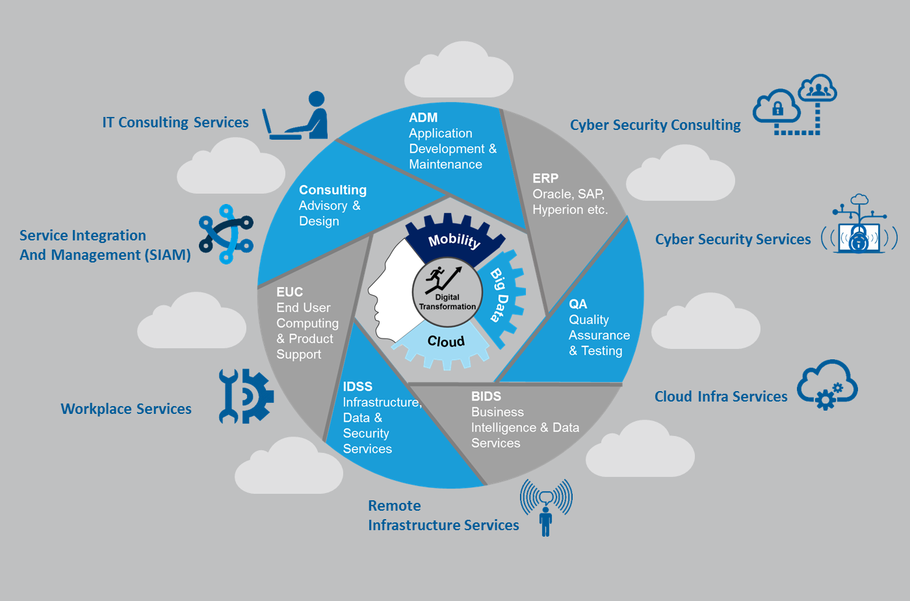

Genpact’s digital IT service practices incorporate best practices associated with its ongoing and progressive global delivery experience, its emphasis on knowledge management and continuous improvement, its deep expertise in innovative and emerging technologies and IT process “design thinking” to effectively and efficiently manage the converged infrastructure requirements of a 21st century banking service, its technology supply chain, and its partner ecosystem.

Genpact effectively helps its clients increase their competitive advantage by increasing speed to market for the business and developing new, technology-enabled banking products and services. Drawing on considerable design, build, and run experience in the broader infrastructure space, Genpact can help Synchrony Financial develop strategies and successfully execute program and project plans to achieve a more responsive, agile, business-aligned, and cost-optimized IT back office.

Whether facilitating the move from bare metal servers to virtualization technologies and/or the evolution to introduce and support single or multi-cloud service architectures, Genpact has “been there and done that” for many of the largest global corporations across all market sectors.

Additionally, Genpact’s Innovation Lab provides an environment where it can partner with suppliers and clients alike to explore and develop leading-edge technology solutions, providing a test bed/sandbox for new tools, API development, and proofs of concept.

**Genpact’s Workplace Services**

End-user computing has changed. Multichannel support is now a must, and >80% of incidents are due to diverse end-user devices, increasing the cost and complexity of support operations. Genpact’s workplace services reimagine end-user touch points by better aligning effective technology and analytics to ITSM processes. This delivers personalized services that enhance business productivity and customer satisfaction, in addition to improving resource productivity and reducing service desk spend.

GENPACT’S INTEGRATED “DIGITAL WORKPLACE” SOLUTION

**ANYWHERE, ANYTIME, ANY DEVICE**

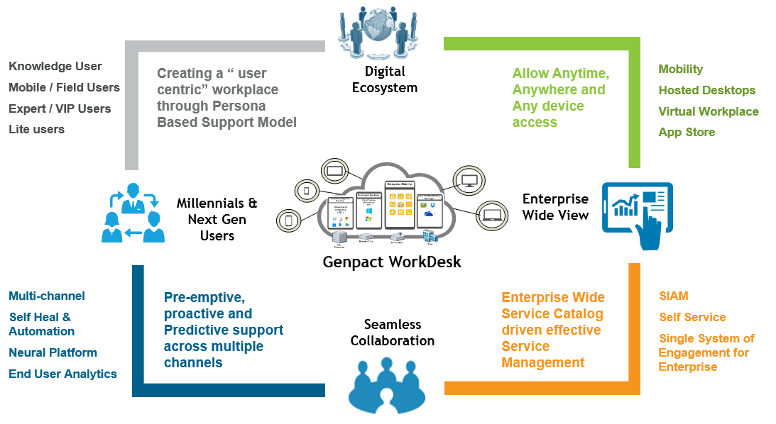

* Personalized services with persona-based user segmentation, culturally aligned support models, and an optimal blend of multichannel support and automation
* Multichannel support where end users can request support from mobile apps, social media, chat, and phone
* IT concierge services (smart bars), which provide white glove support and smart tech support bars, similar to genius bars, to enhance the brand and end-user experience
* Integrated knowledge management for capturing tacit knowledge and then making it available to agents at the point of service itself
* Intelligent automation platforms to eliminate human errors and automate repetitive, rule-based processes
* Global service integrator framework for end-to-end visibility across service providers and the support layer

**Genpact’s Service Integration and Management (SIAM) Services**

SIAM enhances the linkage between technology and business and comprises strategic, tactical, and operational functions that manage the interactions between technology and business ecosystem supply and demand, and ensure the integration and oversight of operations for any/all shared or business services:

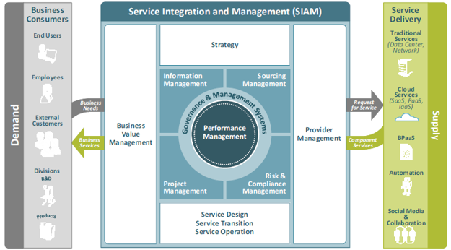

* Service integration and ITIL process advisory
* ITSM implementation for IT and non-IT service portfolios
* Change management (CMDB)
* SLA framework administration
* ServiceNow administration, development, and architecture

**Genpact’s Remote Infrastructure Services**

Whether enterprise needs are centered on data center build and/or consolidation, remote and/or onsite “lights on” support services, or integrated enterprise IT operating models and frameworks, Genpact has extensive experience in managing an ever-expanding range of enterprise infrastructure services.

With its broad expertise in the compute space, including support for UNIX/LINUX (and all UNIX flavors), Windows, VMware, Citrix, and ITAM, Genpact has been delivering on its promise of best-in-class IT services to its global clients – each supported by Lean Six Sigma principles, PMO/PMP-oriented project management methodologies, and quality-driven continuous improvement and best practices.

Genpact’s Digital ROCSM framework delivers to the enterprise a modular and flexible end-to-end service management capability that incorporates strong OEM technology partnerships with its proprietary tools, automation, and analytics capabilities:

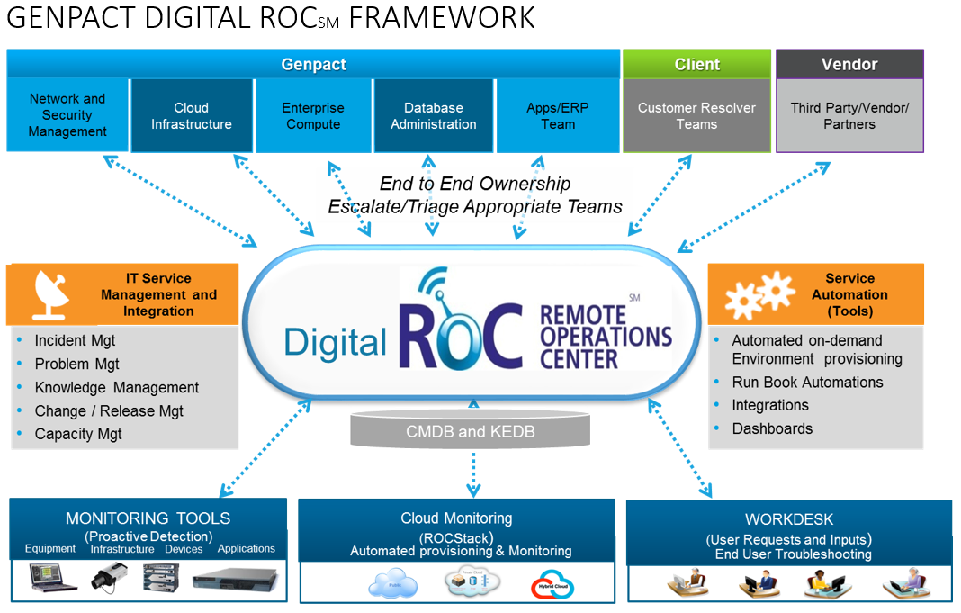

* Compute services such as fine-tuning and transformation through server monitoring and management, server and desktop virtualization, storage and backup management, site build-out, and data center services
* Network services including design and architecture, implementation, and management services through network operation centers, LAN and WAN monitoring and management, and voice management
* Collaboration and unified communication offerings including design and architecture, deployment, and management of e-mail solutions, enterprise mobility, Microsoft Lync, audio/videoconferencing platforms, and documentation/knowledge management
* Professional services including design and architecture, infrastructure assessment, consolidation and migration, standardization, optimization, capacity planning, and disaster recovery solutions

**Genpact’s Cloud Infrastructure Services**

With the evolution of cloud strategies and increasing availability of ecosystem-oriented technology solutions, enterprise IT organizations are increasingly looking at new ways to optimize costs and improve agility and responsiveness of the business. Genpact’s “Cloud in a Box” provides a full suite of engineering and operational support for private, public, and multi-cloud environments, including AWS, Salesforce.com, and MS Azure. Genpact’s domain experts are available to assist the Synchrony Financial team in all manner of cloud and infrastructure readiness and improvement initiatives. Many Genpact engagements today are centered upon the enterprise cloud strategy.

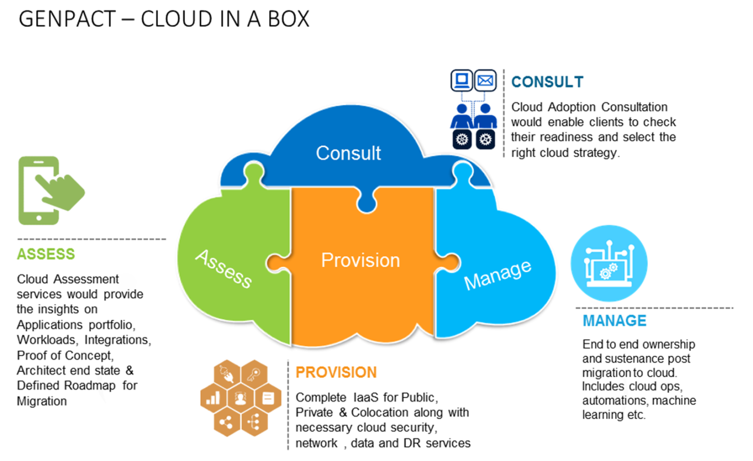

* Cloud strategy and assessment (public, private, hybrid, and multi)
* Cloud adoption – Cloud enablement, migration, development and sustenance, rollouts and environment management, application rationalization, and integration of cloud-based applications with legacy and non-cloud-oriented applications and technologies
* Cloud security consulting and Security Information and Event Management (SIEM) services
* Hybrid infrastructure operational support – Cloud infrastructure performance monitoring and optimization services including multi-supplier tech stacks and architectures, SIAM/ITSM for hybrid private/public/SaaS environments, and cloud-based RIM services
* Cloud orchestration (automation and DevOps tools and frameworks)

**Genpact’s Cyber Security Services**

* Genpact is well versed in the enterprise security architecture, endpoint security, network and web security, application security, advanced threat detection, forensics, identity and access management, IT risk assessments, and the regulatory compliance space, and has a proven track record of servicing many leading global banking and capital markets organizations. Our approach will combine risk management principles, information and cyber security expertise, process banks, maturity models, predictive analytics, flexibility, and technology to help Synchrony Financial significantly improve its cyber security posture considering the current threat landscape.
* Genpact’s “Security in a Box” enables enterprise clients to achieve a robust and impregnable security posture that is tailor-made specifically for its requirements at attractive prices (pay per use) and in a clear and transparent manner on a shared or dedicated platform:

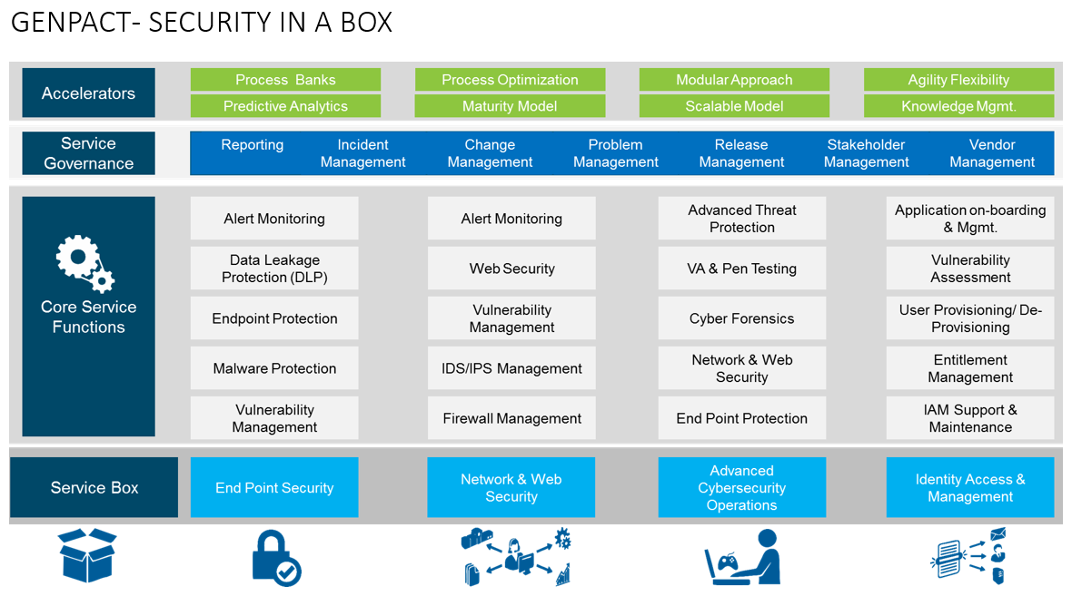

* Advanced Cyber Security Operations and Management (SOC)
* Identity and Access Management (IAM) Services
* Application Risk Management and Security Service
* Advance Endpoint and Mobile Security
* Sensitive Data Risk Management
* GRC and Technology Risk and Compliance Management
* SIEM

**Genpact’s IT and Cyber Security Consulting Services**

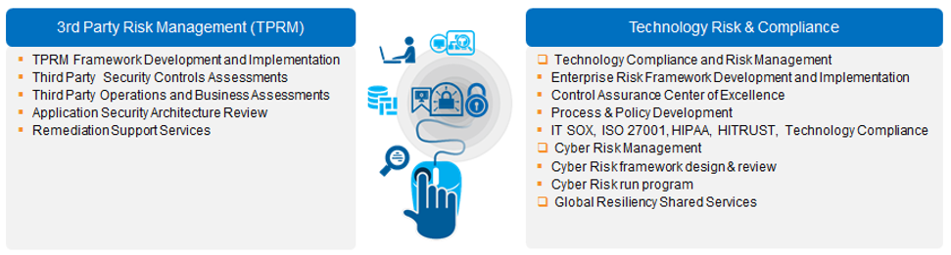

* Enterprise ecosystem tool assessment and consolidation
* Cloud readiness assessment
* Infrastructure transformation consultancy services
* Workplace transformation assessment
* Infrastructure consolidation and optimization strategy
* Third-Party Risk Management (TPRM) – Framework development
* Governance, risk, and compliance framework
* Cloud security assessment

**Our Expertise – In Summary**

Our business focuses on industry verticals in banking and financial services, insurance, capital markets, consumer product goods, life sciences, infrastructure, manufacturing and services, healthcare, and high tech.

Our offerings in these core vertical markets are driven by our broad end-to-end functional and process expertise, which includes:

* Traditional IT services
* Digital IT services
* BI and master data management
* Analytics and data science
* Enterprise application services (development and performance management)
* QA testing/DevOps
* Business and enterprise risk consulting
* Process re-engineering
* Supply chain and procurement services
* Finance and Accounting (F&A) services
* Collections and customer services

At Genpact, we commit to delivering significant business impact to Synchrony Financial by designing, transforming, and running ecosystem-oriented processes that typically combine elements of several of our service offerings. In providing services across our global delivery platform, we draw on core capabilities in process expertise, analytical ability, and technology expertise, as well as the operational insight we have acquired from our experience in managing thousands of processes for our clients.

**Process Expertise**

We have extensive experience in running a wide range of processes and have used this expertise to develop our Smart Enterprise Processes (SEPSM) proprietary framework. We believe that we have built a science of process through SEPSM – a unique and highly granular approach to managing business processes. In addition to efficiency, it focuses on maximizing process effectiveness. We also apply the principles of Six Sigma and Lean to eliminate defects and variation and reduce inefficiency. Our Six Sigma and Lean process rigor also allows us to develop and track operational metrics to measure process performance as a means of monitoring service levels and enhancing productivity.

**Analytics and Data Science Capabilities**

Our analytics and data science research capabilities are central to our ability to improve IT business processes. These capabilities enable us to work with our clients and identify weaknesses in IT processes and redesign and transform them to create additional business value. The confluence of big data, regulatory changes, and social media is causing a major shift in the way businesses operate. We help our clients harness data to identify trends and issues, uncover new insights, identify and prevent future risks, and fine-tune operations to make smarter decisions and meet business goals. We also rigorously apply analytical methodologies, which we use to measure and enhance the performance of our technology services. In addition, we apply these methodologies to measure and improve our own internal functions, including the recruitment and retention of personnel.

**Technology Expertise**

Our IT expertise includes extensive knowledge and integration of third-party hardware, network and computing infrastructure, cyber security and Enterprise Resource Planning (ERP), and other software applications. We also use technology to better manage the transition of processes, automate and run processes more efficiently, and replace or redesign processes to enhance productivity. Our ability to combine our process and IT expertise, along with our Six Sigma and Lean skills, allows us to ensure that Synchrony Financial achieves the full potential of BI platforms and web-based software platforms.

**Operational Insight**

Our operational insight enables us to make the best use of our core capabilities. Our operational insight starts with the ability to understand the business context of a process. We place great value on understanding not only the industry in which Synchrony Financial operates, but also the business culture and institutional parameters within which a process is operated. Operational insight also requires the judgment to determine the best way to improve a process in light of the knowledge of best practices across different industries, as well as an appreciation of what solutions can be fully implemented in the context of the particular business environment (including, but not limited to an enhanced security/risk posture).

1. G’s annual sales volumes for IT services.

With one of the industry’s largest and most diverse information technology practices, Genpact delivers transformational impact to our clients by combining global process leadership, analytics, reengineering, and domain expertise with high-end technology development and operational capability.

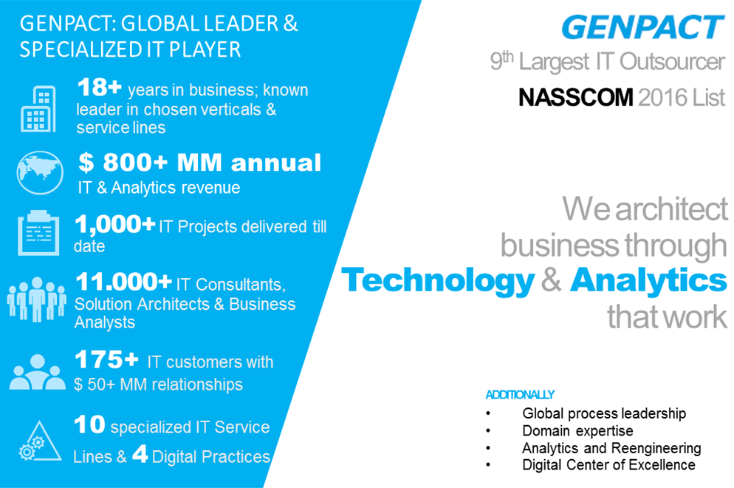

In 2016, Genpact derived approximately 21% ($525 M) of its total revenues ($2.5 BN) from information technology services. Further, exiting 2016, Genpact now employs over 11,000 experts delivering ITO services from our global delivery centers, as well as, client locations.

1. Detail on offshore capabilities.

**Global Delivery Platform**

Genpact oversees a thriving internal and external service delivery ecosystem. A key differentiator for us is our global network of 70+ delivery centers in 17 countries. We also have a number of employees who work on site (in client locations) or provide services from a virtual/remote environment which offers flexibility for both clients and employees.

Our global presence provides us with multi-lingual capabilities, access to a larger talent pool, “near shoring” capabilities to take advantage of time zones or need for local presence, as well as the ability to provide “follow the sun” services. With its global delivery network, Genpact effectively manages complex processes across multiple geographic regions.

We can provide Synchrony Financial with services within and/or across regions depending on the specific needs and/or requirements, the mix of skills, and cost of employees in each location. The choice of delivery center locations are based on a number of factors, which include unique skill sets, the availability and composition of the local talent pool, infrastructure maturity, government and regulatory restrictions (if any), overall operating costs and, Synchrony Financial preference.

We have been an industry leader in opening centers across regions of India as well as within other countries in which we operate. We were one of the first companies to establish operating centers in Dalian, Foshan and Huaqiao, China; Bucharest, Romania; and Gurgaon, Hyderabad, Jaipur, and Kolkata in India. We constantly evaluate new locations, including new countries and new cities within countries in which we currently operate, as potential sites for delivery centers and offices.

Our delivery centers are located in Brazil, China, Colombia, the Czech Republic, England, Guatemala, India, Japan, Mexico, the Netherlands, Northern Ireland, the Philippines, Poland, Romania, South Africa, the United Arab Emirates, and the US.

Genpact’s key US corporate offices include its headquarters located in New York City, NY and a vibrant technology incubation and alliance program development center located in the heart of Silicon Valley in Palo Alto, CA. We pride ourselves in driving seamless delivery with a unified service culture across all operating locations. Growth and geographic coverage does not dilute our flexible and collaborative approach and hundreds of our long-term clients include approximately one-fifth of the Fortune Global 500.

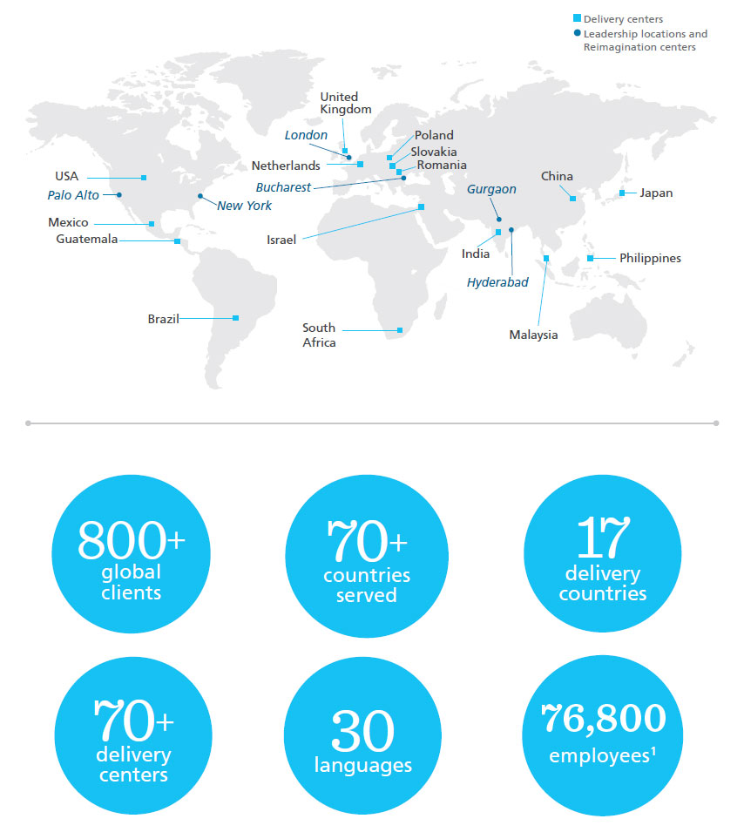

At Genpact, our mission is to deliver services to our clients from locations that best meet their needs; this “right-shore” approach includes – a) onshore, b) near shore, c) offshore, or a combination of global service delivery models – taking into consideration business objectives and cultural needs.

**Our global service delivery capabilities by region are summarized in the table below:**

|  |  |  |  |  |
| --- | --- | --- | --- | --- |
| OFFSHORE | | | | ONSHORE/NEARSHORE |
| **GEOGRAPHY** | **EMEA** | **INDIA** | **ASIA (EXCLUDING INDIA)** | **AMERICAS** |
| Employee | 5,800+ | 57,800+ | 5,700+ | 7,500+ |
| Delivery Centers | Czech Republic, Ireland, Netherlands, Poland, Romania, Slovakia, South Africa, United Kingdom | Bangalore, Delhi, Gurgaon, Hyderabad, Jaipur, Kolkata, Mumbai, Noida | China, Philippines, Japan, Malaysia | United States, México, Guatemala, Brazil |
| Languages Served | Danish, Dutch, English, Finnish, French, German, Greek, Hungarian, Italian, Lithuanian, Norwegian, Pidgin, Polish, Portuguese, Romanian, Russian, Slovakian, Spanish, Swahili, Swedish, Turkish | English, local Indian languages | Cantonese, Chinese, Japanese, Korean, Local Filipino Languages, Malay, Mandarin and South-East Asia Languages, Philippine, Spanish, Cantonese, English, Thai | English, Spanish, Portuguese, French |

Note that all service capabilities detailed in Question 1 can be delivered from Genpact offshore delivery centers.

1. G differentiators in the marketplace

Key organizational strengths that differentiate us from our competitors are listed below:

**Globally Effective – Cost Conscious**

Seamless delivery anywhere, anytime: We deliver our services form a global network of centers located in 17 countries across 70+ delivery centers. Our mission is to deliver services from locations that best meet Synchrony Financial needs – onshore, offshore, near shore, or a combination of global service delivery models taking into consideration business objectives, cultural needs, language requirements and cost containment strategies.

**Operational Excellence**

Helping Synchrony Financial run its business better: Operating excellence has been our value-creating engine for clients. It describes our holistic approach for meeting and exceeding the client expectations, enabling a flawless execution of the client’s day-to-day operations, consistently driving continuous improvement, and achieving desired business outcomes. It is supported by a rigorous measurement methodology to ensure that “what gets measured gets controlled”. Our frameworks, such as Smart OpEx framework, Common Minimum Practices (CMPs) and Alert ensure the process stability.

The quality, agility and rigor of our operating excellence framework is powered by the single largest pool of dedicated Lean and Six Sigma experts in the industry, including 16,000+ Six Sigma and 42,000+ Lean-trained employees. Over the years, with social media, collaboration tools, and expert communities, we have strengthened collaboration among internal teams, with clients and external experts. With commitment to productivity improvements driven by innovations in analytics and automation technologies, the resulting operating excellence that has led to more than 80% our growth from the existing clients and 100% contract renewals.

**Genpact Lean DigitalSM**

Our unique investment for driving impact: Genpact has made significant investments to establish its unique Lean DigitalSM approach, which enables large companies to redefine their middle- and back-office operations and achieve measurable impact, such as growth, cost efficiency, and business agility. This approach drives digital impact by architecting how enterprises run from the front-end to the middle and the backend. It aligns digital interventions to what generates measurable business outcomes, and navigates complex legacy processes and technologies.

Lean DigitalSM harnesses three complementary domains: Digital process-centric technologies, design-thinking methods focused on end customers, and Lean principles focused on agility. Specifically, Lean DigitalSM leverages business transformation methods, such as Genpact’s patented SEPSM framework, SoETM solutions, related digital integration services, and Data-to-ActionSM analytics, which, when combined, create Intelligent OperationsSM, able to sense, act effectively and efficiently, and learn from their actions.

**Deeply Embedded Customer-centricity**

Clients like Genpact: We always place our clients before us and believe in long-term partnerships based on trust. For more than a decade, the Net Promoter Score (NPS) has been our most critical measure of success. It measures, monitors, and builds customer loyalty. NPS is a way of life for us – and a key differentiator of our service delivery approach. In 2016, we had an NPS of 63%. Unsurprisingly, 80% of our annual growth comes from the existing clients and we have retained 99% of our clients in the last three years.

**People Strategy**

A global supply chain of talent: Genpact has a diverse global workforce, which allows us to support an extremely wide range of geographies and corporate cultures. We also have a high-performance employee acquisition, retention, and training program that delivers best-in-class service through best-in-class talent.

**Best in Talent Retention**

We have one of the lowest attrition rates in the industry; many benchmark studies conducted by independent bodies such as the National Association of Software and Services Companies (NASSCOM) have captured the attrition trends in the BPO industry and have stated that Genpact’s attrition is half the industry’s average. Our attrition rate for all employees who have been employed by us for one day or more was 26% in 2016.

**Pioneers in BPM**

We are the world leader in BPM and technology services with experience of 18+ years. We were an early mover in the industry and a pioneer in many areas that have strengthened the concept of BPM. Few significant firsts include the first to introduce Virtual Captive model, a mature global sourcing model which delivers best-in-class services through dedicated resources, top management support, people, technology, and infrastructure, the first to use Six Sigma for process transitions, the first to build a KPO practice, the first to set up services in Eastern Europe to serve clients in Western Europe, the first to develop the science of process, Smart Enterprise ProcessesSM (SEPSM).

**Proven Stability and Growth**

A partner you can rely upon, Genpact has consistently posted robust revenue growth and is well known for its transparency and global reach. As a result, clients that choose Genpact benefit from having a dependable partner that can work on their most important issues today and in the future. Key pillars of our strength include:

* 800+ clients and 76,800+ people
* Healthy CAGR of 14.7% (24.8% excluding GE)
* Global management
* Stable margins and high free cash flow conversion
* Strong board of directors

1. Case studies

Each client infrastructure environment, requirements, and challenges are unique. Accordingly, each Genpact solution and areas where the most impact can be gained, are equally unique and environment dependent.

We have a highly reference able client base of 800+ clients from diverse industries, business sizes, and processes. Our clients include 120+ of the Fortune Global 500 and of those, 40+ of the Fortune Global 100; amongst them 9 of the top 10 investment banks, 2 leading US banks, 2 leading Australian banks, 4 global telecommunications providers, 10+ blue chip healthcare clients, 2 of the top 3 logistics providers, and 4 of the world’s largest breweries. Our existing client base accounts for 80% of our annual growth.

The following table reflects a selective but representation of Genpact clients, similar in structure and complexity to Synchrony Financial, where we have been engaged to deliver infrastructure related solutions to critical enterprise challenges. In each and every instance, Genpact has delivered to the needs of client and has achieved the measurable impact derived from one or more the following solution levers:

* Business process view using Six Sigma and process reengineering with analytics, improving end-to-end performance metrics, boosting year-on-year productivity, and reducing TCO by up to 30%
* Integrated operations platform reducing support and maintenance costs while offering the enterprise a better view of key performance characteristics
* Technology and intellectual property driven operations maturity model
* Best practice-based IT optimization and standardization
* Continuous cost out, using Genpact's unique ShiftLeftSM approach to reduce costs and enhance value

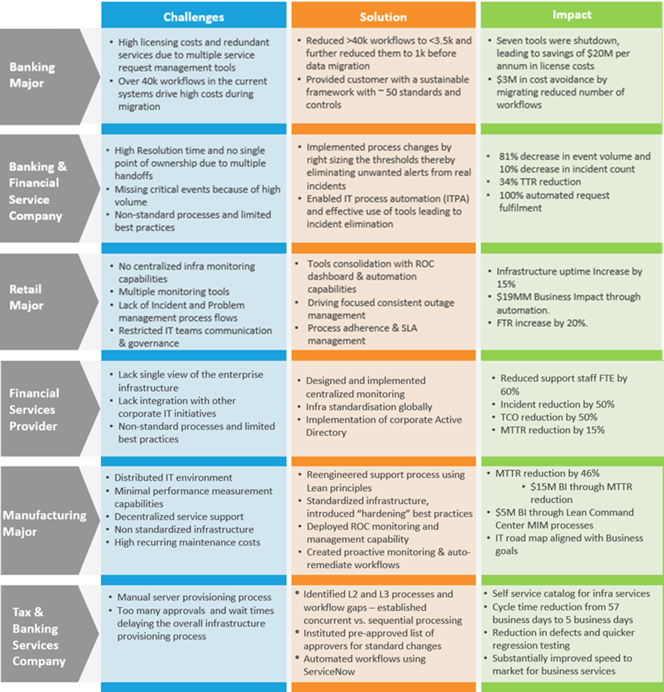

Our focus is on overall business impact, which is the cumulative effect derived from lowering costs, improving the customer or vendor relationship, and boosting revenue. We can proudly say that we deliver an estimated $1.5 BN of business impact to our Banking and Financial Services clients annually. We look forward to bringing all our levers to bear to provide Synchrony Financial with an unparalleled return on their investment in a future and long-lived Genpact partnership.

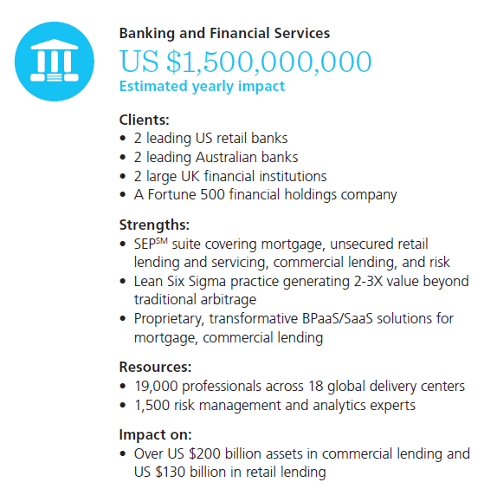

Some of our implemented productivity/efficiency methodologies include:

**Genpact’s Lean DigitalSM Approach**

Lean DigitalSM harnesses three complementary domains: digital process-centric technologies, design-thinking methods focused on end customers, and Lean principles focused on agility. Specifically, Lean DigitalSM leverages business transformation methods, such as Genpact’s patented SEPSM framework, SoETM solutions, related digital integration services, and Data-to-ActionSM analytics, which, when combined, create Intelligent OperationsSM able to sense, act effectively and efficiently, and learn from their actions. It aligns digital interventions to what generates measurable business outcomes, and navigates complex legacy processes and technologies.

**LSS**

Unlike many companies, who have simply embraced LSS as a function, since our inception, Genpact has driven it through the entire organization and put it to work for all our clients, and delivered enhanced value. We take a different approach to implementation of LSS, going beyond the scope of the contract to take a comprehensive upstream/downstream view, which extends our impact on client’s businesses. By being proactive in driving efficiency gains and working with clients to reengineer processes end to end, we integrate better with our clients operations, creating a seamless process environment. Our focus is always on our client’s business, not ours. This defines the culturally ingrained, hard-to-replicate DNA of Genpact – 16,000+ Six Sigma Green Belt-trained employees, 42,000+ Lean-trained employees, 600+ Black Belts and Master Black Belts, and 50% of our top leadership is LSS certified.

**SEPSM**

The IP accumulated over 18 years of doing an enormous number of LSS projects became the foundation for our SEPSM methodology. SEPSM is a logical and unique methodology that employs granular data analysis, ultra-sophisticated diagnostics, cross-functional benchmarks and technology solutions to maximize process effectiveness, and end-business outcomes. The results are better cost, cash, and revenue outcomes for our clients.

**Reengineering**

Our reengineering service is an optimal blend of Lean and Six Sigma customized for varied needs. Genpact’s reengineering focuses on driving process improvement projects with clients for core processes that may not necessarily be outsourced in the short term.

**Smart OpEx Framework**

Our robust Smart OpEx framework ensures surprise-free operations and high-quality services to our clients. It has been designed keeping in mind the end goal of having an integrated operational excellence framework, which is a comprehensive support to an operating lead to deliver predictable, low risk, and high-quality performance. With experience of managing over 6,000+ processes in multiple industries and markets, we have developed a framework that proactively identifies the weak spots, problem areas, and makes operating deliverables predictable by bringing visibility to gaps on critical process controls as well as softer operating disciplines.

**Business Process Management System (BPMS)**

We use the BPMS methodology to create a Performance Management System for processes. BPMS is a methodology designed specifically to ensure that the improved processes are able to sustain gains and perform consistently at the desired levels. Dashboards are the key tools used for tracking metrics, detailed analysis of defects, comparison of volumes, and associate-wise performance summary. The client can use the dashboards to track performance across all parameters. The methodology helps us get a comprehensive view of the processes and define the key metrics for the processes.

**Benchmarking**

Genpact, through the years, has developed a set of benchmarks to measure the efficiency and effectiveness of a process and has been partnering with its clients to achieve these. We have invested in our dedicated practice teams, who have built the industry-leading best practices and benchmark similar processes across clients from multiple industries at a granular sub-process level. The practice organization regularly reviews the processes for each client. The approach we follow in developing these benchmarks is as follows:

* Collating metrics and data pertaining to the SLAs for the “As-Is” process during the planning stage
* Identifying a master list of metrics for production support by leveraging the industry-wide best practices and experiences from other engagements
* Understanding the client requirements and deciding on metrics that will help achieve the client objectives
* Base-lining the service level performance for six months after the service take-on date and establishing the target SLA
* Monitoring of minimum best practices through regular audits by the Practice team

Moreover, to monitor operations and the impact generated by us on a near real-time basis and provide complete transparency and visibility, Genpact has employed a number of reporting tools and systems such as dashboards, daily status trackers, monthly self-assessments, etc., depending on the business requirement.

1. Industry awards received in the past 18 months (i.e., Gartner Magic Quadrant, etc.).

Genpact has been recognized and received numerous awards. A snapshot showing some of our recent awards and accolades is as follows:

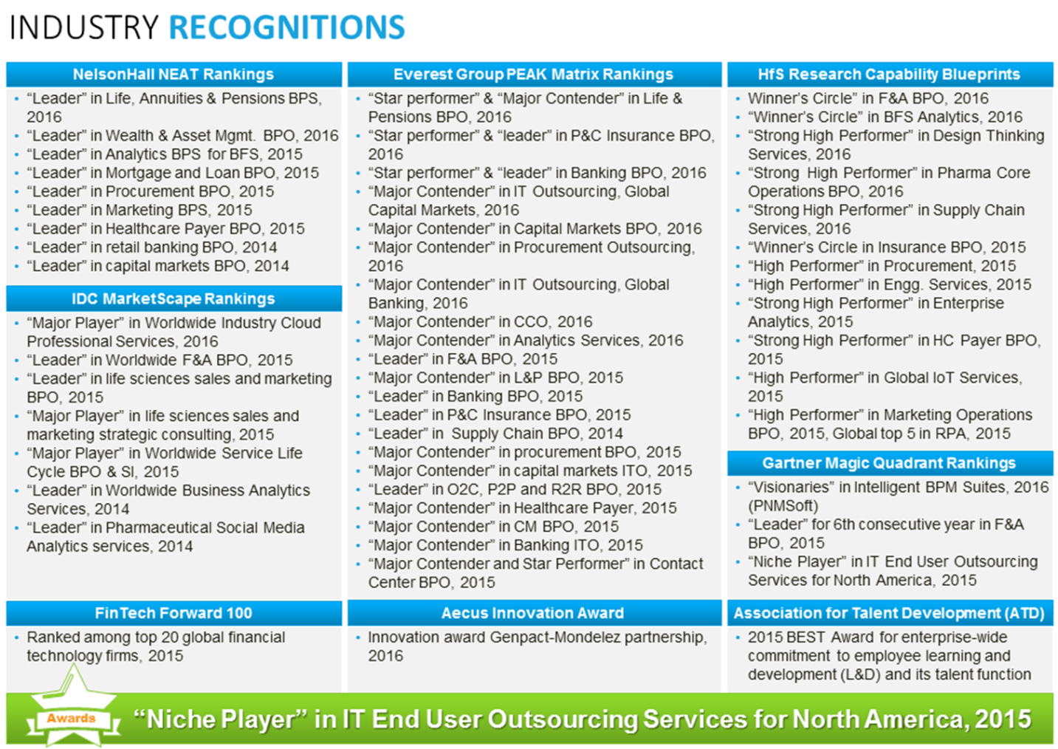

1. Overview of G’s professional memberships or certifications:
2. **International Standards Organization (ISO)**

Genpact conforms to several ISO standards (associated with) and for IT service providers, internal and external audits of ISO standards are conducted for Genpact information systems to ensure the compliance with relevant ISO standards. In addition, Genpact holds its partners to the same standards and ensures compliance on, minimally, an annual basis.

1. **PCI Standards Council, The Information Security Audit and Controls Association (ISACA)**

Genpact has instituted PCI DSS controls for a number of its clients on requirement basis. The PCI DSS audits are conducted in accordance with client compliance and audit requirements. Genpact Information Security teams continuously monitor standards of organizations and governance structures as they are either introduced or matured in terms of broader market or market sector adoption. Often, practices are introduced and adopted based upon recommendations of these (standards) associations and/or in accordance with the dynamic regulatory and compliance needs of our clients.

1. **Information Systems Security Association (ISSA)**

Not applicable. Genpact Information Security teams continuously monitor standards of organizations and governance structures as they are either introduced or matured in terms of broader market or market sector adoption. Often, practices are introduced and adopted based upon recommendations of these (standards) associations and/or in accordance with the dynamic regulatory and compliance needs of our clients.

1. **Microsoft, Red Hat, Cisco, etc.?**

Genpact’s technology bench maintains up-to-date training and the recent certifications to assure its ability to meet the technology needs of its clients. These include, but are not limited to certifications in Microsoft, RedHat, CISCO, etc. A snapshot of our more commonly required certifications is as follows:

|  |  |
| --- | --- |
| A snapshot of our more commonly supported technologies | |
| Hardware Platforms |  |
| * HP – servers (rack and blade) and midrange * Cisco – routers, switches, servers (blade) and anti-spam devices * IBM – servers (rack and blade), midrange servers, SAN systems, and backup systems * Dell – servers (rack and blade) * EMC – SAN and NAS systems * NetApp – NAS systems * F5 – Application security manager (ASM) devices * Sonicwall – Aventail SSL VPN server |
| Software and Application Platforms |
| * Microsoft Windows Server platforms * Citrix – XenApp, XenServer, XenDesktop * VMware – Vsphere, ESX Plus Virtual Desktop (3.5+), VMware View (4+) * Microsoft Exchange – management and tuning * Microsoft Active Directory – management and tuning, domain management, and PKI management. * Unix environments – includes Linux (SUSE Linux Enterprise and Red Hat), HP UX, AIX, and Sun Solaris * ServiceNow |

In addition to the above certifications, Genpact has defined quality controls in line with the internationally accepted standards and certifications at the organizational level to service our clients. These quality standards and certifications have been highlighted below:

|  |  |  |
| --- | --- | --- |
| QUALITY STANDARD | ASSESSING ORGANIZATION | SCOPE OF APPROVAL |
| Entity Controls | | |
| ISAE 3402 | ISAE | System, suitability of design, and operating effectiveness of controls  (41) Genpact service delivery centers in 12 countries ISAE 3402 Type II certified |
| ISO 27001 | BSI | Information security management for call centers, transaction processing, and accounting services |
| ISO 22301 | BSI | Business continuity management system |
| SOX | KPMG | Adherence to the Sarbanes–Oxley Act, 2002 |
| CMMi Level 3 | CMMI | Projects performing development, enhancement, maintenance, and work-type testing |
| PIPA | Dalian Software Industry Association | China’s highest standard for personal information protection regulation in IT outsourcing services |
| ISO/IEC 20000 | BSI | IT service management standard describing an integrated set of management processes for an effective delivery of services to the business and its customers |
| Environment, Health, And Safety (EHS) Controls | | |
| OHSAS 18001 | BSI | EHS activities of program management, IT services, centralized service desk, desktop support, network, voice infrastructure support server, database support, HR training, and security management |
| ISO 14001 | BSI | Internationally accepted standard for an effective environmental management system (EMS) |
| Business-Specific Controls | | |
| PCI DSS | Various | Conducted for specific processes at clients’ request and expense |